Joystick Mapping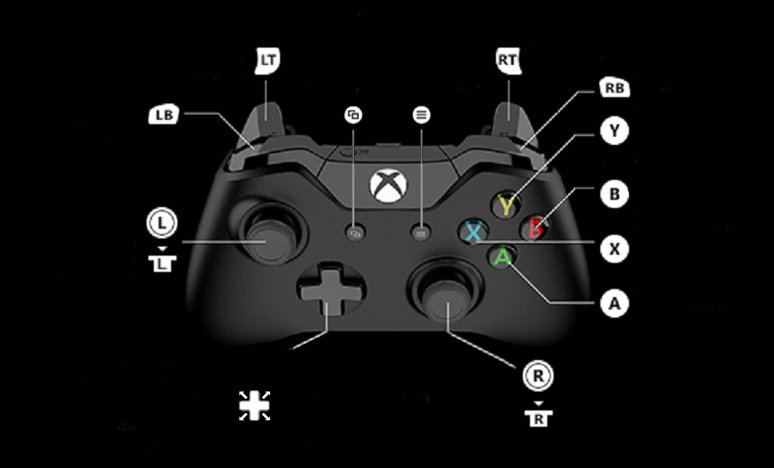 V2

*Trigger Left: Intake push*

*Trigger Right: Intake pull*

*Bumper Left: Arm cycle down*

*Bumper Right: Arm cycle up*

*A: Arm manual down*

*X: Arm manual up*

*B: Wrist manual down*

*Y: Wrist manual up*

*D-Pad Up: Wrist up (90 degrees)*

*D-Pad Down: Wrist down (0 degrees)*

*D-Pad Left: Hatch push*

*D-Pad Right: Hatch pull*

*Y axis Left: Tank drive left*

*Y axis Right: Tank drive right*

*R/L X axis not used*

*Back 7 not used*

*Start 8 not used*

*L stick button 9 not used*

*R stick button 10 not used*

*Game bar button does not register in driver station*